**A/D Conversion Module, Timer0, and the banksel Directive**

**Name (Print):**_____REZA SHISHEIE_____________________**ID**____2708062______

**Due date:**

MW Section – Wed, Feb 14

TTh Section – Tue, Feb 13

Give brief answers to the following questions. You can use this document to insert your answers. They can be typed or handwritten, but they must be neatly written. Only hardcopies will be accepted, no emails. The assignments must be submitted on or before the due date before the beginning of class. The score for late labs will be reduced by 10% if the lab is submitted after class on the due date. The score will be reduced by 20% if submitted by the beginning of the next class day after the due date. After that, the score will be zero.

Calculations should be carried out to four significant digits, and any formulas used should be shown, even if the formula is trivial. This will maximize your potential for partial credit.

1. (1 pt) According to the datasheet, what are the Special Function Registers (SFRs)? (One sentence).   
     
   **Ans.**   
   The Special Function Registers are registers used by the CPU and peripheral modules for controlling the desired operation of the device
2. (1 pt) How many bits are in each Special Function Register and where are the contents of the registers located?  
     
   **Ans.**

SFRs are 8 bit long and they are on static RAM or SRAM.

1. (1 pt) There are two places in Section 2-2 of the datasheet where the default **power-on reset** (POR) values of the STATUS register are listed. What are they and what pages are they on?  
     
   **Ans.**

One of them is on Table 2-1 page 15 and the default value is 0001

The second one is at table Register 2-1 page 18 and it is 0001

1. (1 pt) What is the value of the STATUS register after a POR? What does the ‘x’ mean?   
     
   **Ans.**

0001 1xxx

x means Bit is unknown

1. (1 pt) What is the POR value of STATUS<RP1:RP0>?  
     
   **Ans.**

RP1 = 0 and RP0 = 0

1. (1 pt) Which bits in the STATUS register are not writable? (State the bit numbers and the mnemonics).  
     
   **Ans.**   
   TO and PD are not writable. The bit numbers are bit-3 and bit-4. The mnemonic is TO and PD
2. (1 pt) What is the default bank after a POR? Explain.  
     
   **Ans.**

The default value of POR is 0001. The first two on the left are 00 by default and Table Register 2-1 on page 18 says that if the 2 most significant bits are 00, it means that it is on Bank 0

1. (1 pt) There is another type of reset which occurs during normal operation of the chip called the **master clear reset** (MCLR). What is the value of the STATUS register after a MCLR? What does the ‘u’ mean? (Hint: See Section 12.)  
     
   **Ans.**

STATUS is < 11uu > and u means unchanged

1. (1 pt) Build the lab02.asm source code. The hardware does not have to be connected. Select **View → Disassembly Listing** in MPLAB. Find the first banksel directive. Notice that this directive has been assembled into two instructions. List the two instructions, and also write the instructions using the mnemonics.  
     
   **Ans.**0001 1283 BCF 0x3, 0x5
2. (1 pt) If Bank 1 is selected, the instruction MOVF PIE1, W will copy the contents of the PIE1 register to the W register. What will happen if this instruction executes when Bank 0 is selected?  
     
   **Ans.**the content of PIR1 will be copied into W
3. (1 pt) Build and upload the lab02 code. Select **View → Program Memory** in MPLAB.   
     
   a) What are the contents of the 0x1EC9 program memory address? Show your answer in hex and binary.  
      
   b) What are the contents of the 0x1F00 program memory address and what is the meaning of the contents? (Hint: Open the Help/Topics menu in MPLAB and find the PICkit 3 help section. Search for “Resources”)  
     
   **Ans.**a) hex = 3FFF, binary = 0011 1111 1111 1111

b) the value is RRRR and it means that: In the IDE, program memory and/or data memory (file register) displays marked with an 'R' represent reserved registers.

1. (2 pts) When using the PICkit3 in debugging mode, certain resources on the PIC are reserved for the debugger. (Hint: See Chapter 12 in the datasheet.)   
     
   a) Which pins on the PIC (by pin name and number) are reserved for the PICkit3 debugger?  
     
   b) Which program memory addresses are reserved? (Answer in hex.)  
     
   c) Which data memory addresses are reserved? (Answer in hex.)  
     
   d) How many stack levels are reserved?  
     
   **Ans.**
2. RB6, RB7
3. Address 0000h must be NOP -- Last 100h words
4. 0x070 (0x0F0, 0x170, 0x1F0) -- 0x1EB - 0x1EF
5. 1 level
6. (1 pt) How many words are there in program memory?  
     
   **Ans.**

Up to 8K x 14 words of FLASH Program Memory,

1. (1 pt ) Suppose ADCON1 = 0x0A.   
     
   a) Which port pins (by name) will be implemented as digital I/O pins?   
     
   b) What value needs to be loaded into ADCON1 in order for all of the PORTA bits to be digital? Use ‘don’t cares’ (x’s) for any bits that do not relate directly to the answer of this problem. (Hint: Check the ADCON1 register description in Chapter 11 of the data sheet.)   
     
   **Ans.**a) ADCON1 = 0x0A = 0000 1010 🡪 AN7(1) RE2 and AN6(1) RE1

b) 011x

1. (1 pt ) If TRISB = 0x55, which PORTB bits will be inputs and which will be outputs?  
      
   **Ans.**   
   TRISB = 0x55= 01010101

1 is input and 0 is output

Bit0, Bit2, Bit4, Bit6are inputs

Bit1, Bit3, Bit5, Bit7 are outputs

1. (1 pt) Consider the second btfss instruction in lab01.asm. Which instruction is executed next if ADIF = 0? What if ADIF = 1?

**Ans.**

ADIF: A/D Converter Interrupt Flag bit

1 = An A/D conversion completed

0 = The A/D conversion is not complete

If ADIF is 1 it means that the conversion is complete and it skips the next instruction (goto WaitForConversion) and executes next instruction : bcf PIR1, ADIF

If ADIF is 0 it means that the conversion is not complete and thus it executes the next instruction (goto WaitForConversion) and returns back to loop

1. (1 pt) Suppose that the oscillator frequency is *FOSC* = 3.6864 MHz and   
   OPTION_REG = 0000 0011.   
     
   a) What is the TMR0 register time period  in microseconds? (Hint: see the lab02 slides.)  
     
   b) What is the rollover time for the TMR0 register in milliseconds?  
     
   **Ans.**a) OPTION_REG = 0000 0011. 🡪 PS2:PS0 = 011 🡪 Prescale = 1/16

Ttmr = 4/F*prescale = 17.36 us  
  
b) Rollover Time = 4/F * prescale * 256 = 4.4 ms

1. (1 pt) Suppose the pushbutton control in lab02 were configured as shown below. What must be changed in the LoopWhilePushed loop so that the action of the pushbutton remains the same? (Hint: Only one instruction must be changed.)  
     
   **Ans.**

btfsc PORTB, 0

If PORTB<0> = 0, skip the "goto" instruction.

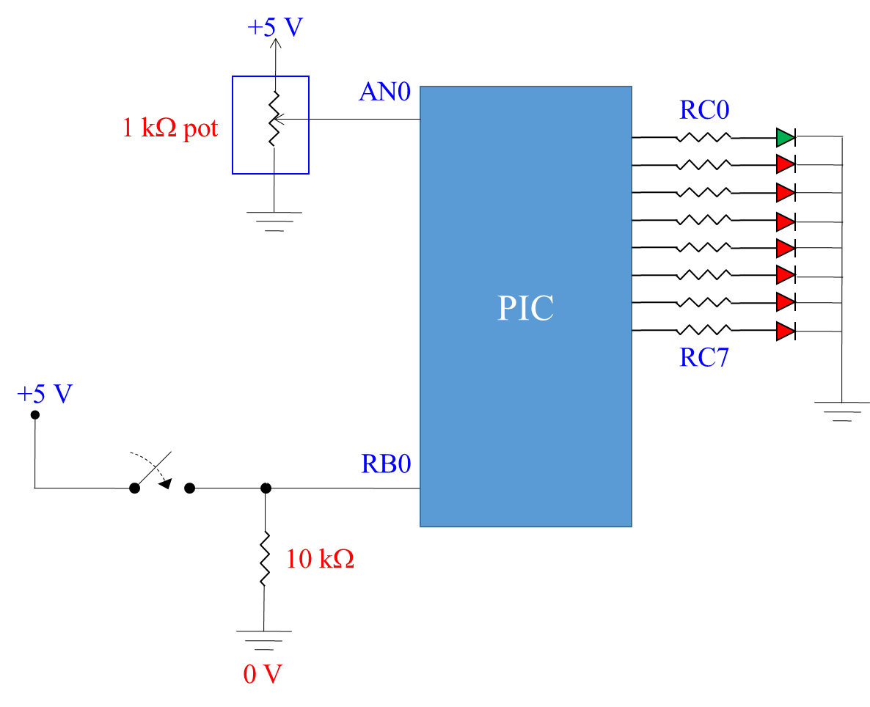

1. (1 pt) The 10-bit ADC module on the PIC has reference voltages of Vref + = 5115 mV and   
   Vref - = 0 V.   
     
   a) If the analog input voltage is 1.967 V, what is the 10-bit digital value?  
     
   b) If the digital output is 11 1000 0001, what analog voltage range does this represent?  
     
   **Ans.**   
     
    a)   
   resolution = (Vref(+) – Vref(-)) / (2^n-1) = 5mv

D = [ (1967 – 0) x ( 1023 / 5115) ] = 393.4 🡪 floor D = 393 = 0110001001

b)  
D = 11 1000 0001 = 897

Analog range = (897 + ½ +/- ½ )(5115/1023)

Analog range = (897.5 +/- ½ )(5)

Analog range = 4487.5 +/- 2.5

1. (5 pts) For lab02, set the analog input voltage to about 2.6 volts. What should the decimal and binary output be? Run the program and demonstrate the LED output to the TA or instructor.   
     
   Output = ON – OFF – OFF – OFF – OFF – ON – ON – ON

Binary = 10000111 = 135

2.6/5*256 = 133

**Student Name** ____REZA SHISHEIE_______________________________________  
  
**Instructor/TA** ___________________________________________ **Date**__________

1. (15 pts) Create a new folder called lab02_Timer0. Place a copy of lab02.asm in the new folder and rename it to lab02_Timer0.asm. Create a new MPLAB project called lab02_Timer0 in the new folder, and add lab02_Timer0.asm to the project. Build the program, program the PIC, and run the project to verify that your software and hardware still functions the same as lab02.  
     
   **Remove all the code related to the A/D converter from lab02_Timer0.asm**. We will not be using it in this exercise. Do not remove the Timer0 code.  
     
   Create a loop so that PORTC is initialized to 1111 1111 and use the decfsz instruction to decrement PORTC until it reaches 0000 0000. This will cause the LEDs to automatically count down from 1111 1111.  
     
   When PORTC rolls over to 0000 0000, use a goto instruction to jump out of that loop into a loop called LoopUntilPressed which will loop indefinitely until the button is pressed. When the button is pressed, jump back into the loop which decrements PORTC.   
     
   When you run the program, the LEDs should count down from 255, rollover to 0000 0000 (all off) and then stop. When you push the button, they should count down again from 255, rollover to 0000 0000, then stop again.  
     
   Calculate the rollover time (show formulas) and enter it below. Use a clock or stop watch to demonstrate the approximate PORTC rollover time to the instructor/TA. Record the rollover time. You will be asked by the instructor or TA to explain how the code you modified works.  
     
     
     
     
   **Calculated rollover time (ms) ___18.3 seconds__________________  
     
   Measured rollover time (ms) ______18.20____________  
     
   Instructor/TA signature and date: ______________________________________**